LAB 10 – Authentication, Session Management & Notifications
1. Overview
This lab guides students through building authentication and user management features in Flutter step by step.
Each lab task is implemented as a separate runnable Flutter project, allowing students to verify each feature independently.
After completing all parts, students integrate all features into a final full project.
Local Notification is a mandatory part of this lab to ensure students achieve LO7 – integrating notifications in mobile applications.

2. Learning Outcomes
After completing this lab, students will be able to:
- Implement authentication flows using mock backend and real REST APIs
- Manage user sessions using local persistence
- Implement auto-login and logout mechanisms
- Integrate Firebase Authentication (Google Sign-In)
- Integrate local notifications after key user actions (LO7)

3. Prerequisites & Tools
- Android Studio
- Android Emulator or physical device (API 33+ recommended)
- Flutter SDK (stable channel)
- Internet connection (required for REST API & Firebase)

4. Required Packages & References
- DummyJSON Authentication API
https://dummyjson.com/docs/auth
- SharedPreferences
https://pub.dev/packages/shared_preferences
- Firebase Authentication
https://firebase.google.com/docs/auth
- Firebase packages
firebase_core, firebase_auth, google_sign_in
- Flutter Local Notifications
https://pub.dev/packages/flutter_local_notifications

5. Submission Rules
5.1 Required Submissions
Students must submit ALL of the following:
Part projects (each runs independently):
- Lab10_1_MockLogin
- Lab10_2_RealApiLogin
- Lab10_3_AutoLogin_Logout
- Lab10_4_FirebaseGoogleSignIn
- Lab10_5_Notification
Final integrated project:
- Lab10_Full

5.2 Naming Convention
- Lab10_1_MockLogin
- Lab10_2_RealApiLogin
- Lab10_3_AutoLogin_Logout
- Lab10_4_FirebaseGoogleSignIn
- Lab10_5_Notification
- Lab10_Full

5.3 Submission Format
- Each project must be compressed as a .zip file
- Each submission should include a short README describing:
  - How to run the app
  - Test account (if any)

6. LAB TASKS
Lab 10.1 – Mock Login (Backend Simulation)
Goal
Build a login screen with validation and simulate backend authentication.
Description
Students create a login UI and simulate a backend authentication process using a mock service.
This lab focuses on UI structure, validation, and basic authentication flow.
Steps
- Create project Lab10_1_MockLogin
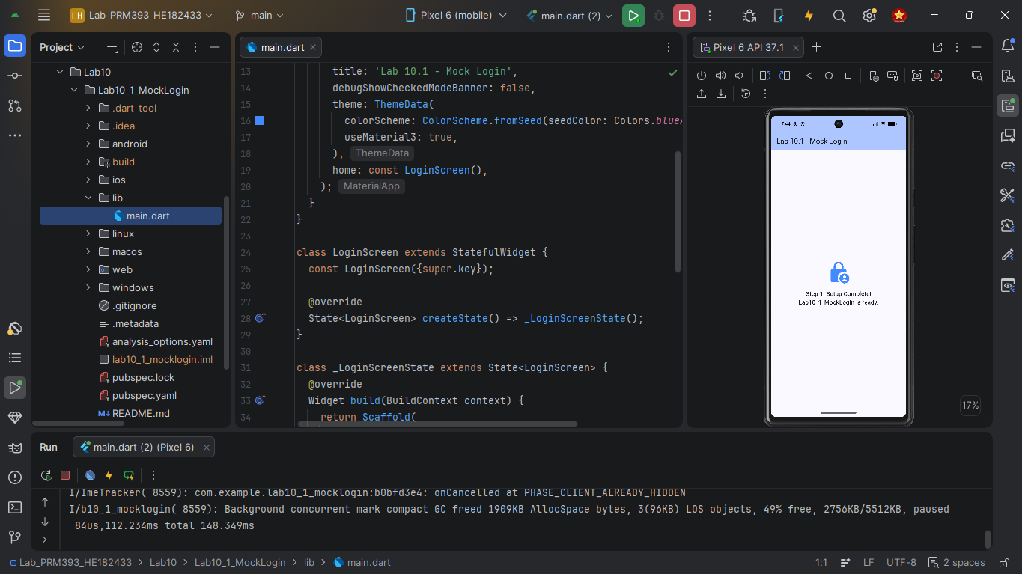
- Build Login UI (email, password, login button)
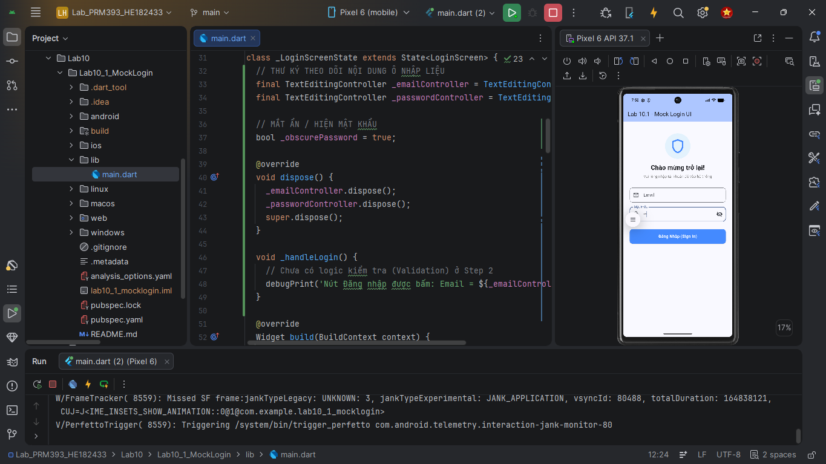
- Validate input using Flutter Form
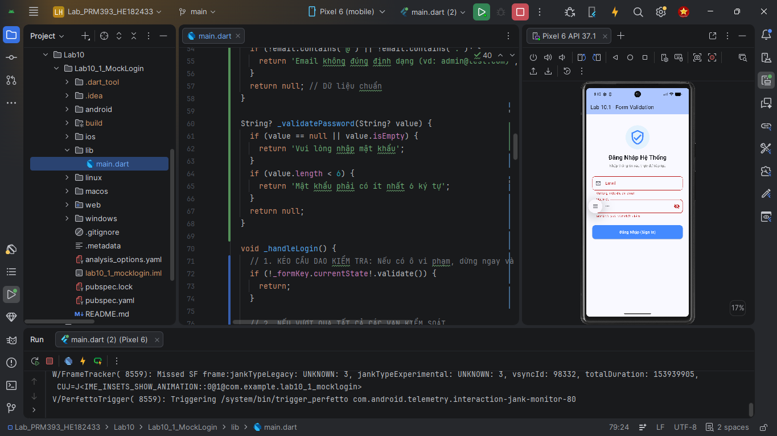
- Simulate authentication with a delay and mock token
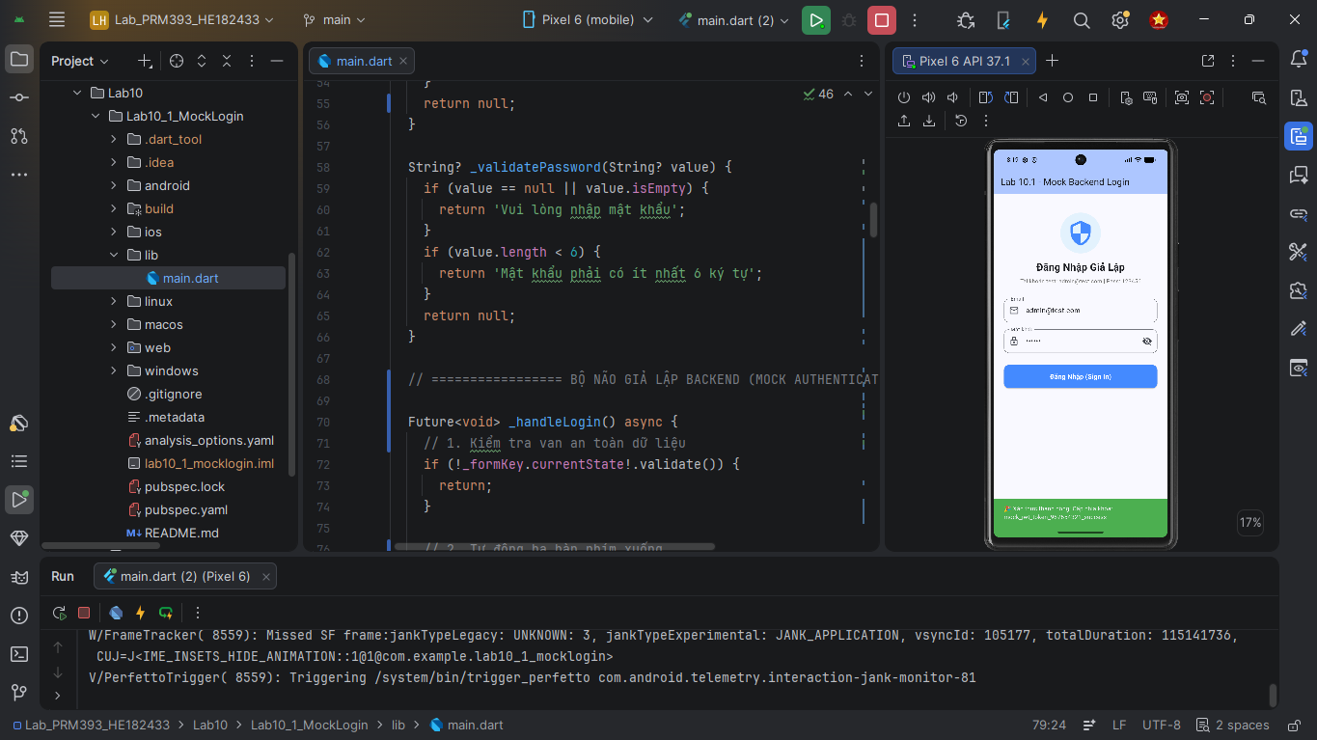
- Navigate to Home screen on success
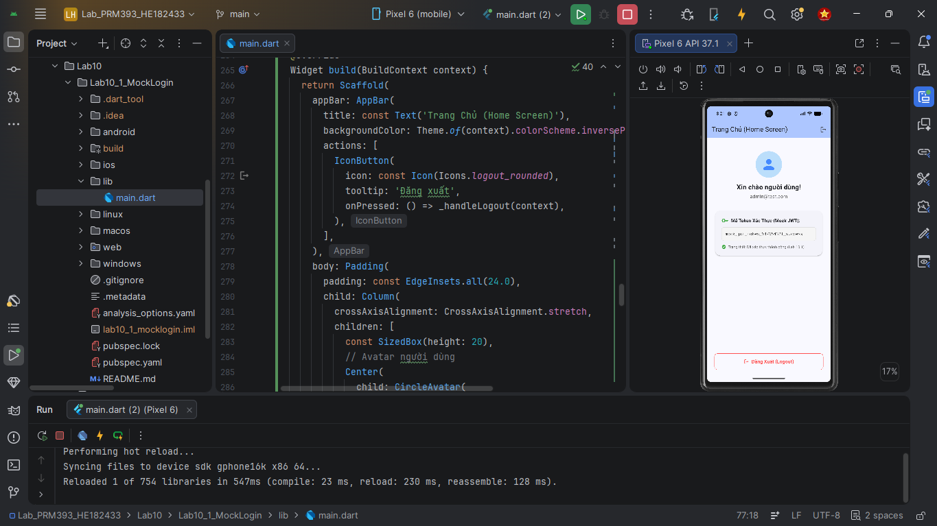
Expected Output
- Valid credentials navigate to Home
- Invalid credentials display an error message
Lab 10.2 – Real REST API Login
Goal
Authenticate users using a real REST API (DummyJSON).
Description
This lab replaces mock authentication with a real HTTP login request.
Students practice handling API responses, loading states, and errors.
Steps
- Create project Lab10_2_RealApiLogin
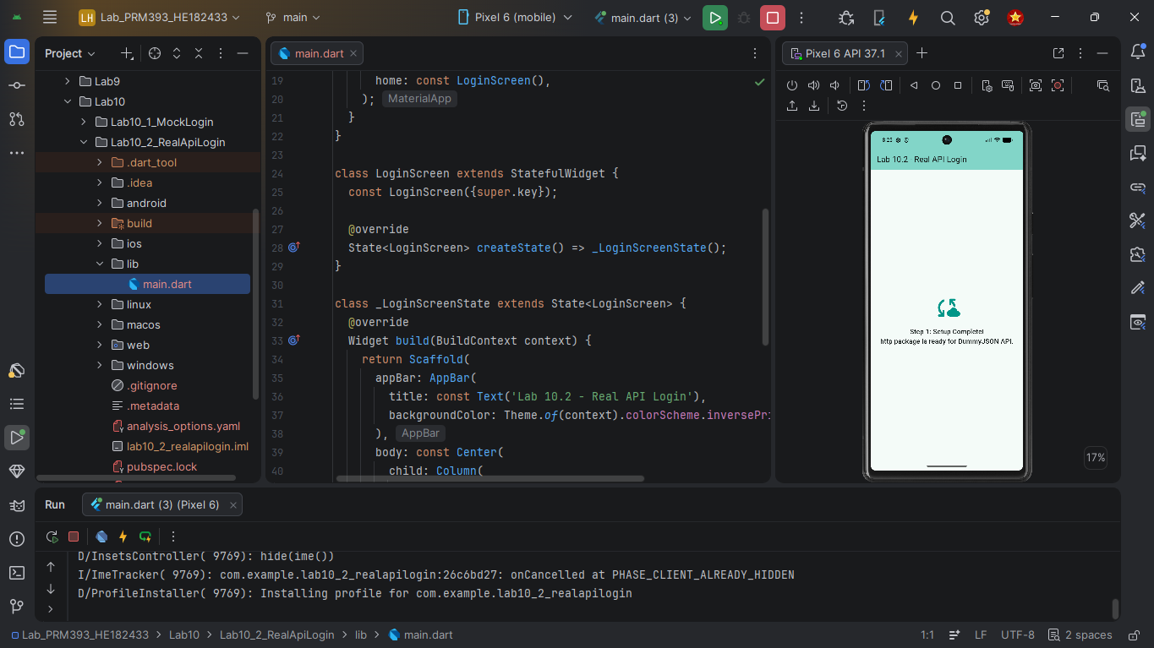
- Send POST login request to DummyJSON
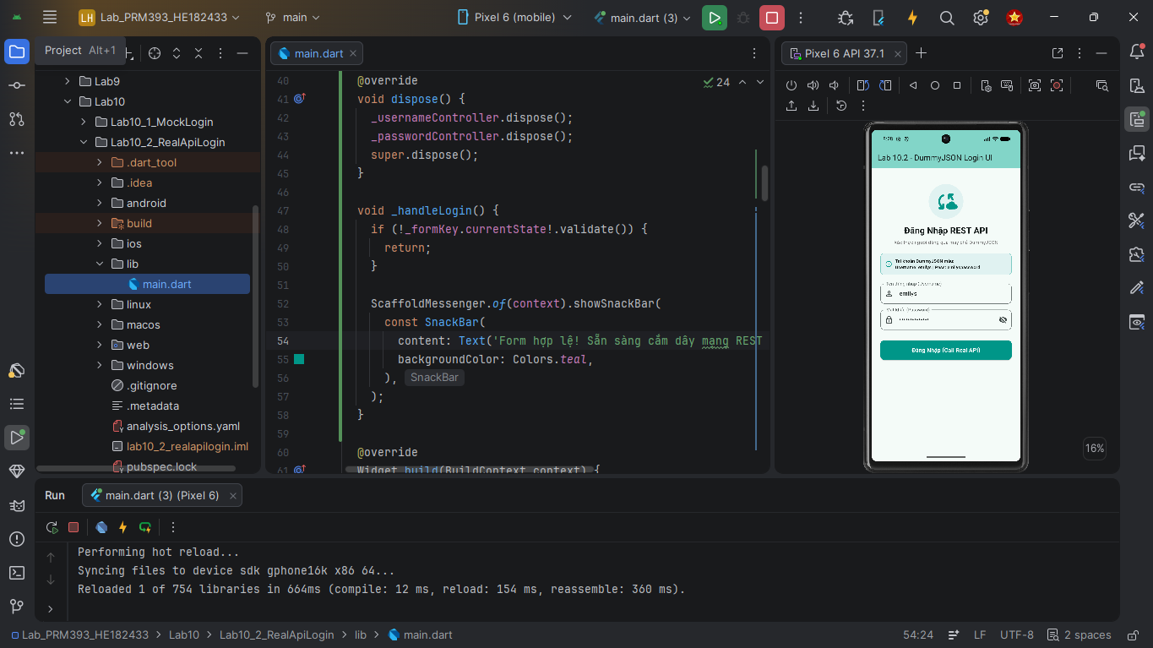
- Parse token from response
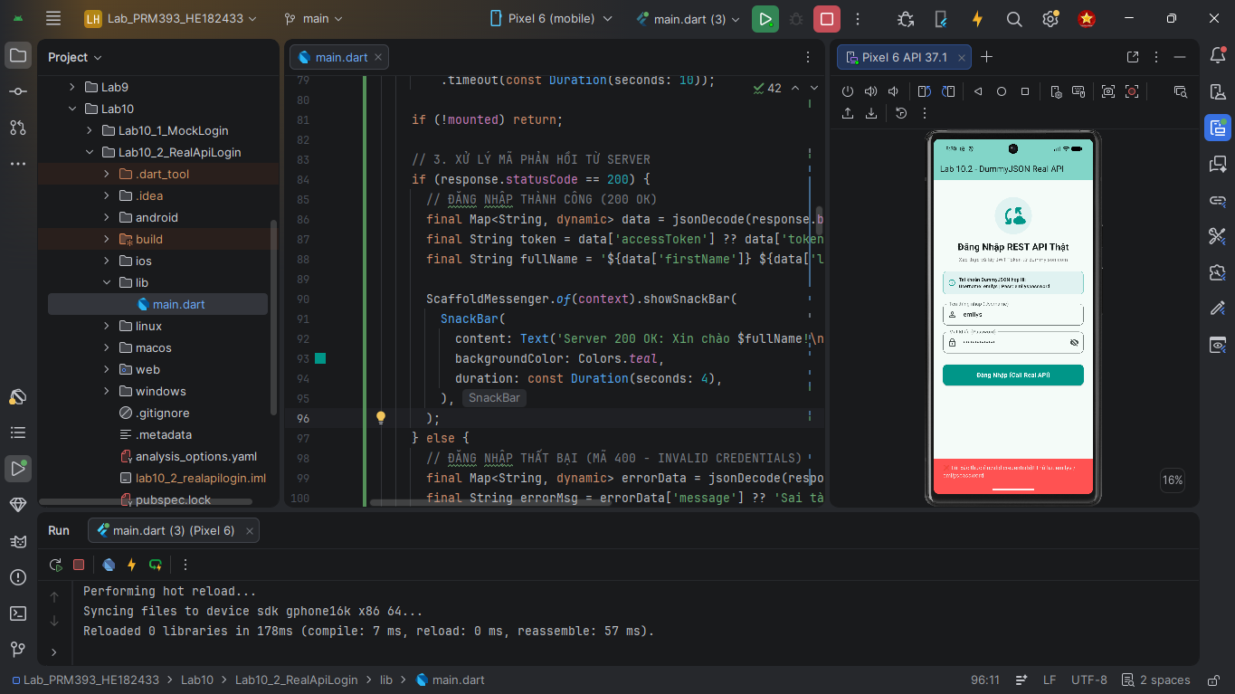
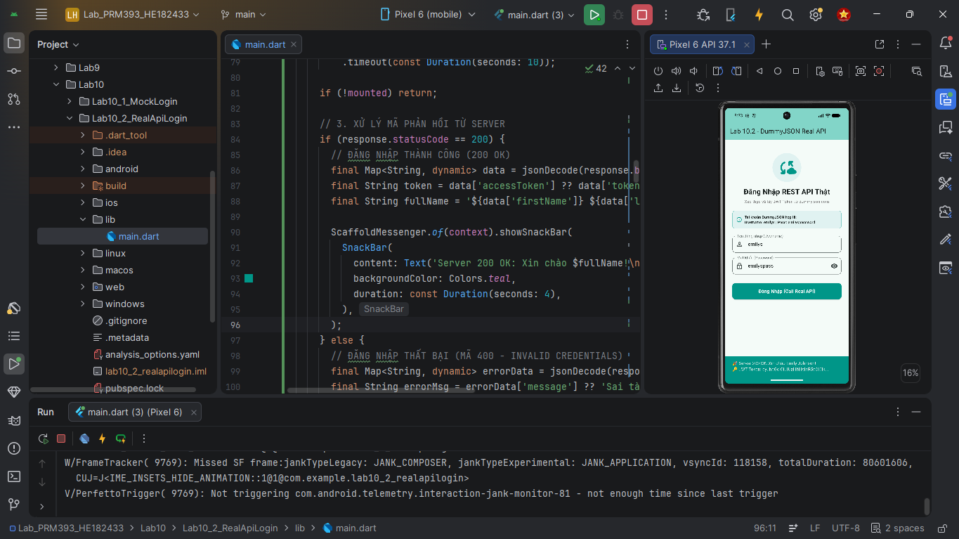
- Handle loading and error states
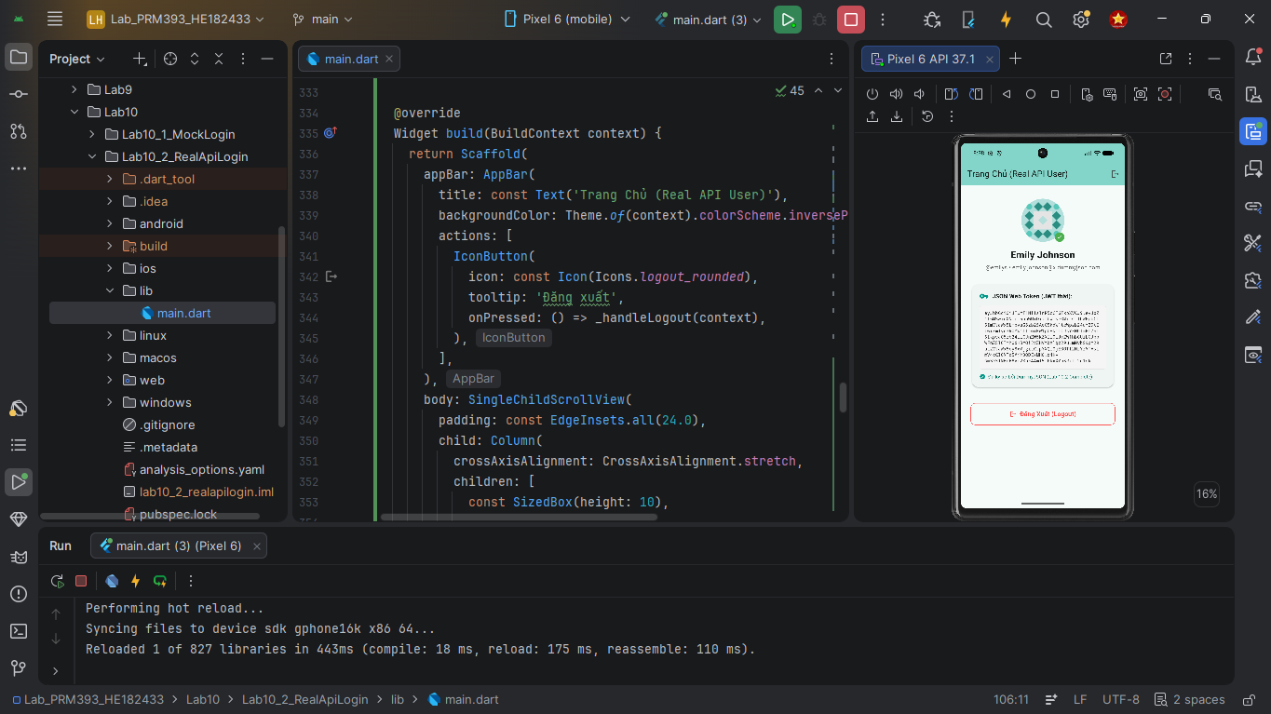
- Navigate to Home on success
Expected Output
- Login succeeds using real API
- Errors are handled gracefully
Lab 10.3 – Auto Login & Logout
Goal
Persist authentication state and restore login automatically.
Description
Students implement session persistence using SharedPreferences and manage login state across app restarts.
Steps
- Create project Lab10_3_AutoLogin_Logout
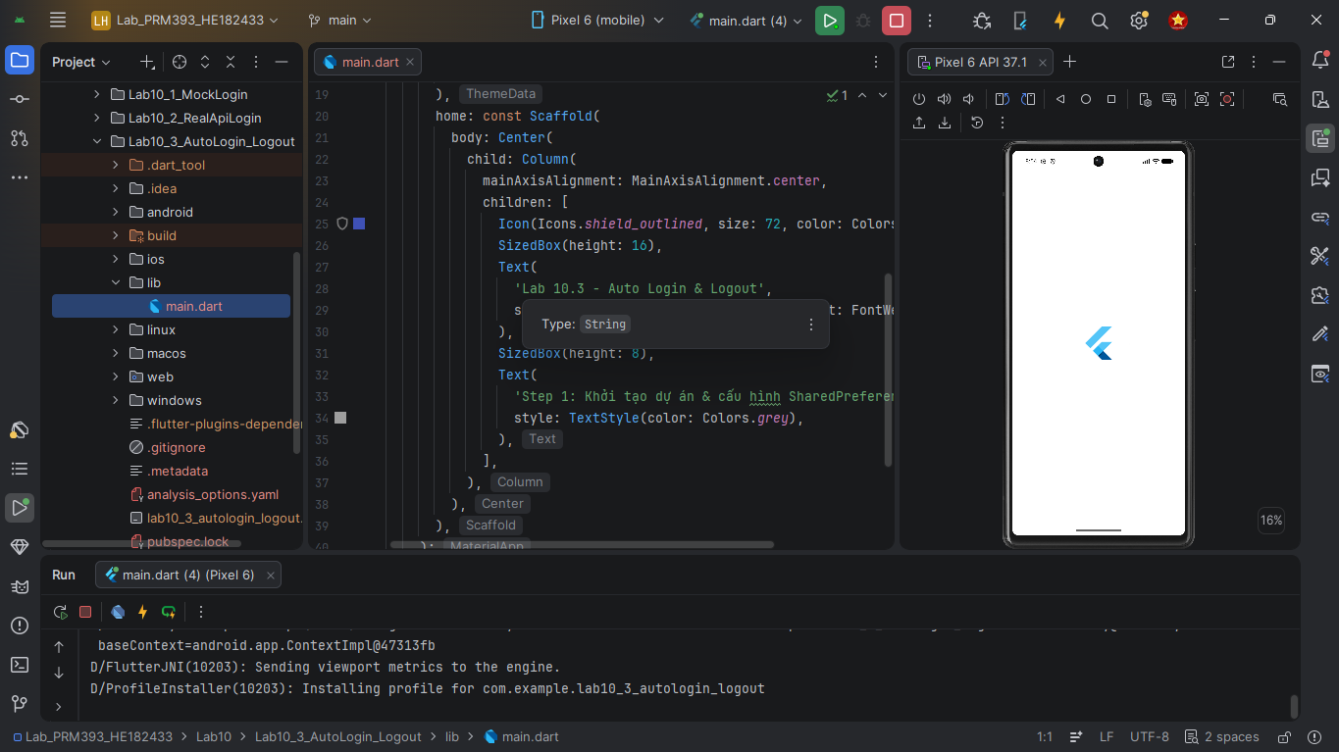
- Save token after login
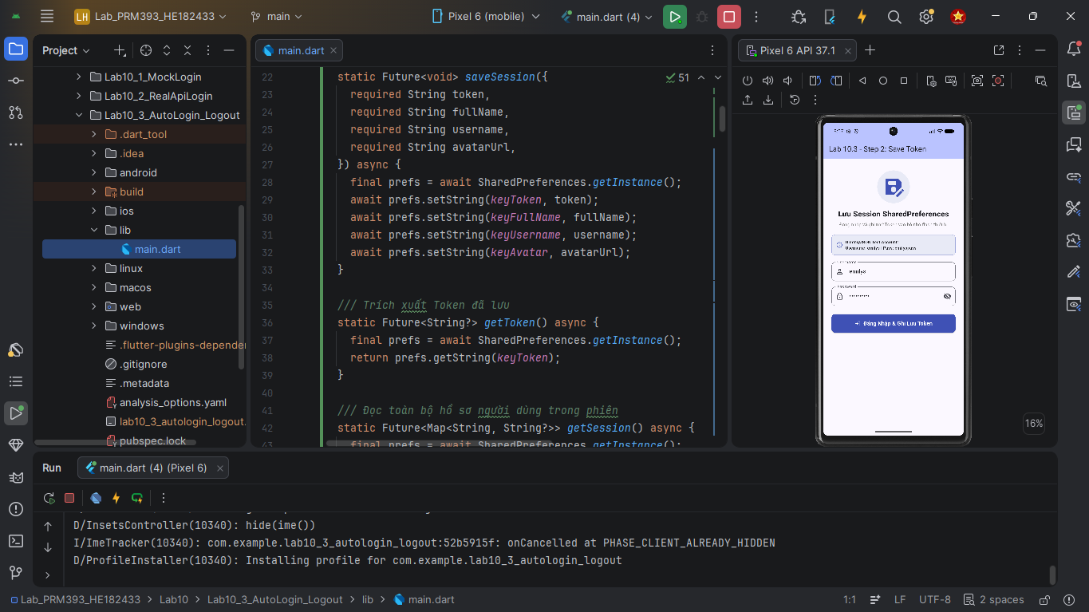
- Implement SplashScreen routing
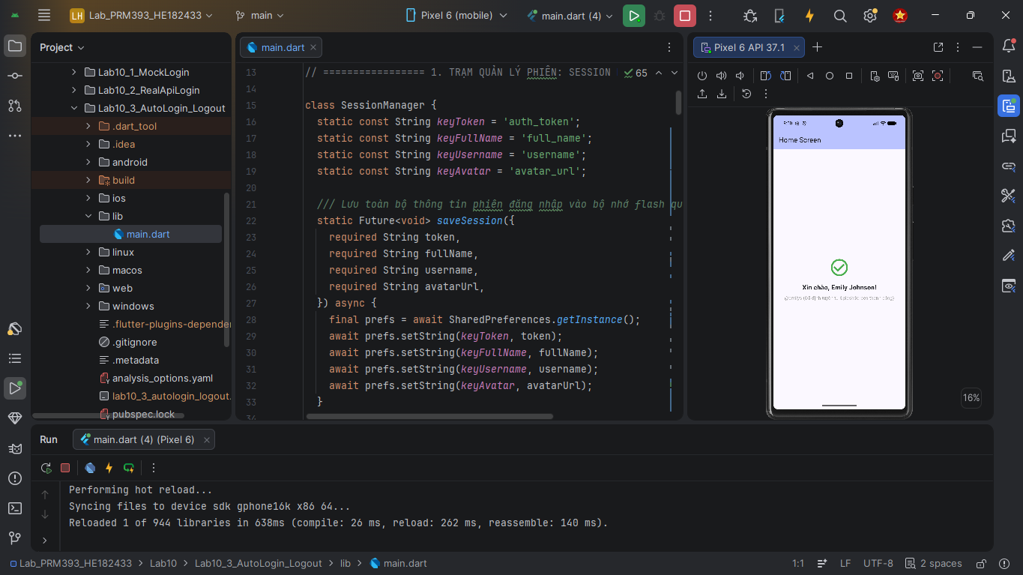
- Auto-login if token exists
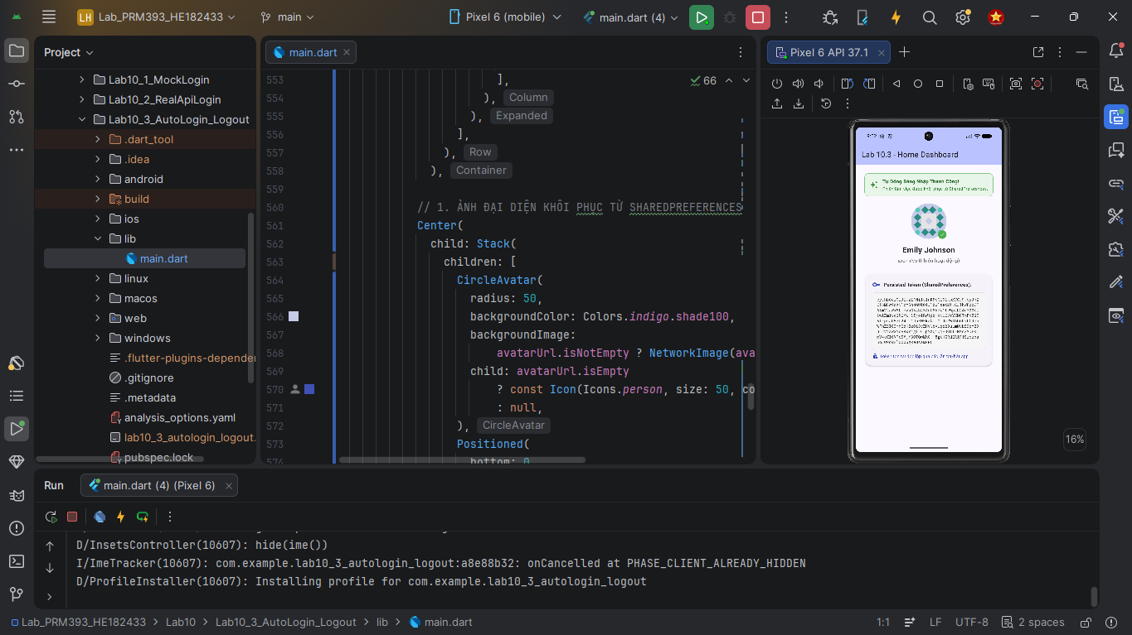
- Logout clears session and returns to Login
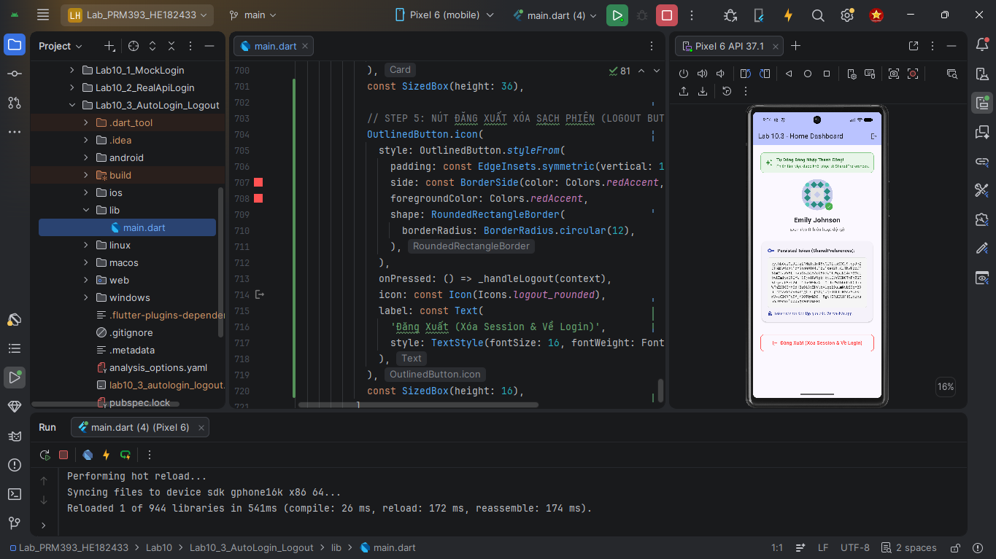
Expected Output
- App skips login when token exists
- Logout forces re-authentication
Lab 10.4 – Firebase Authentication (Google Sign-In)
Goal
Integrate Google Sign-In using Firebase Authentication.
Description
Students configure Firebase and implement Google Sign-In as an alternative authentication method.
Steps
- Create project Lab10_4_FirebaseGoogleSignIn
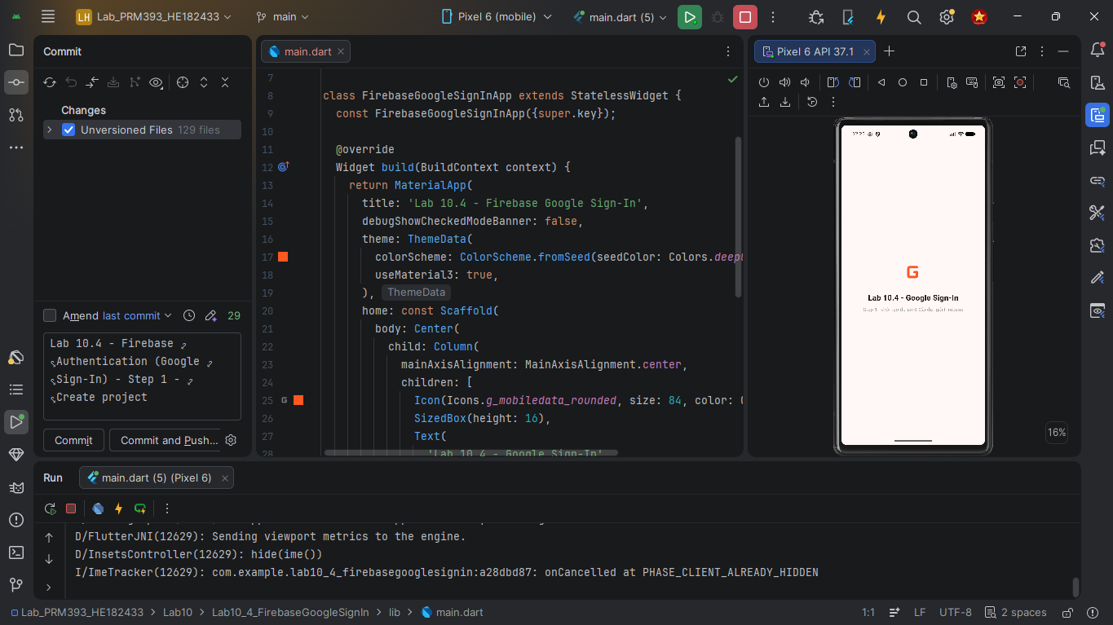
- Configure Firebase project and SHA keys
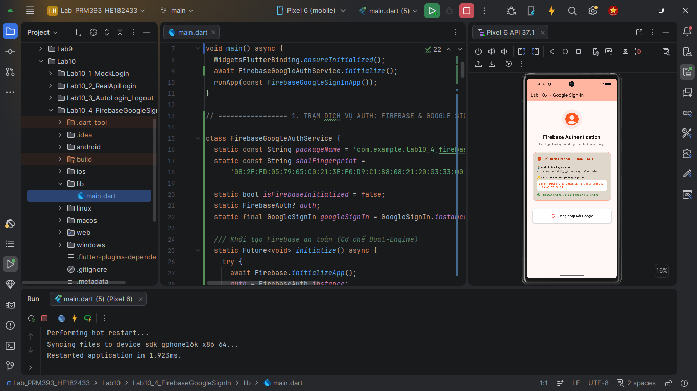
- Implement Google Sign-In flow
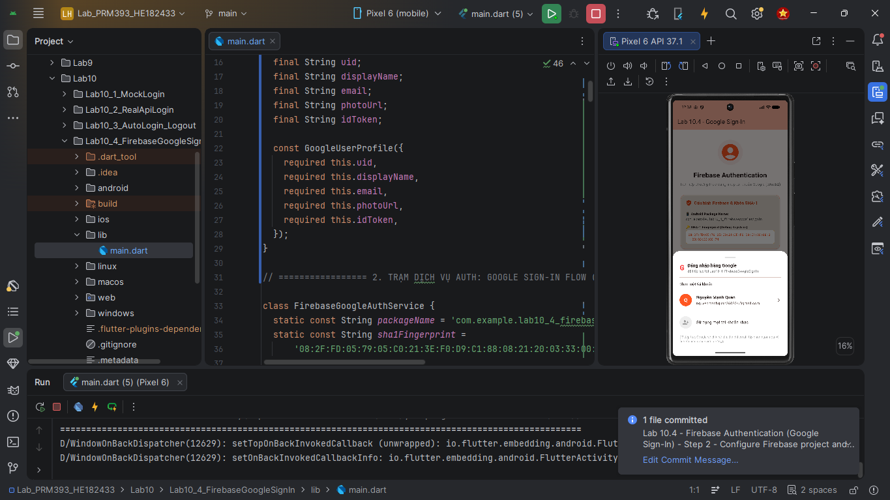
- Display user profile information
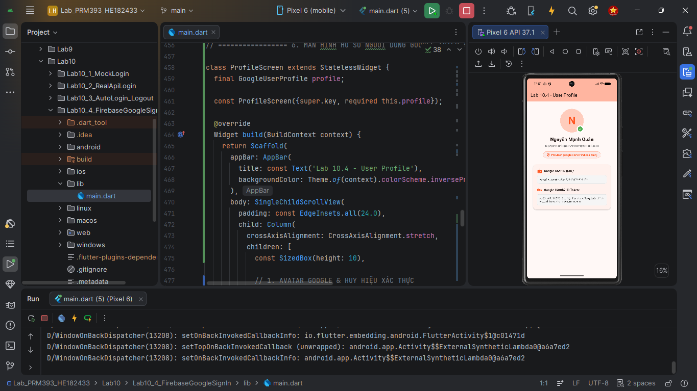
- Logout from Firebase and Google
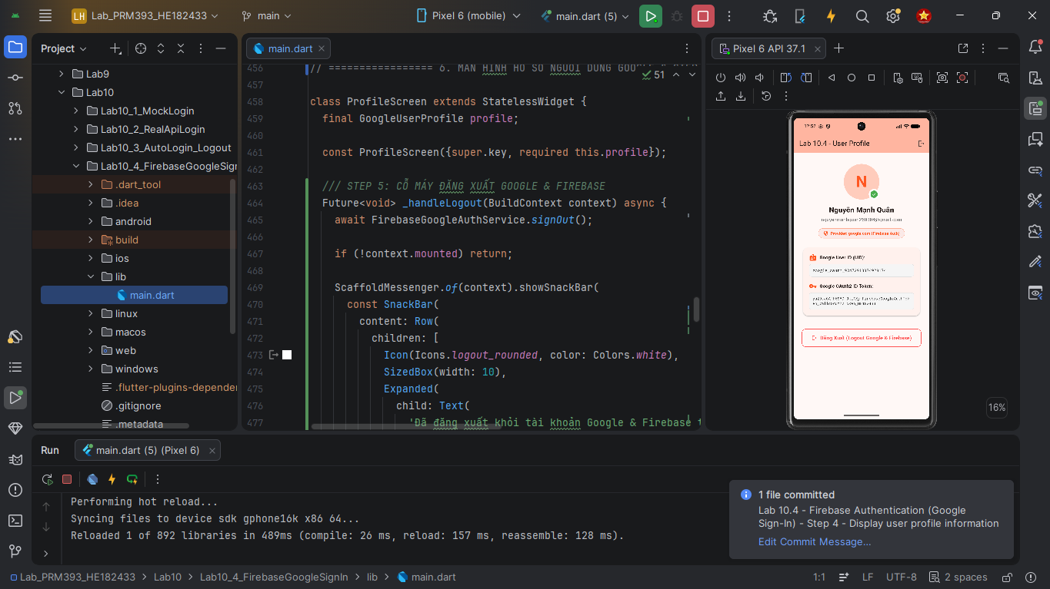
Expected Output
- Google Sign-In works correctly
- User profile is displayed
- Logout returns to Sign-In screen
Lab 10.5 – Local Notification (MANDATORY – LO7)
Goal
Integrate local notifications in a Flutter application.
Description
Students integrate local notifications to enhance user experience after important user actions.
Steps
- Create project Lab10_5_Notification
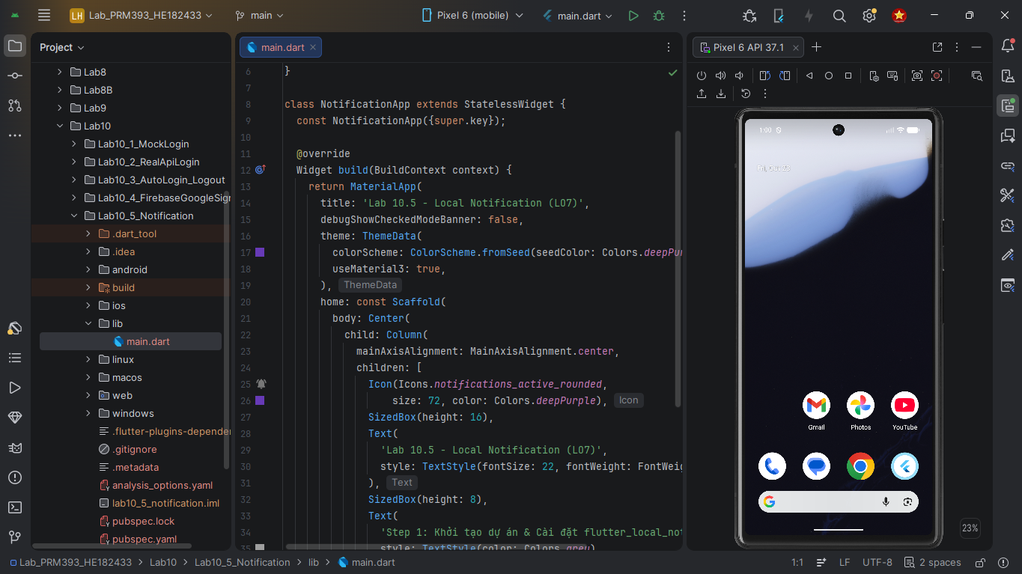
- Setup flutter_local_notifications
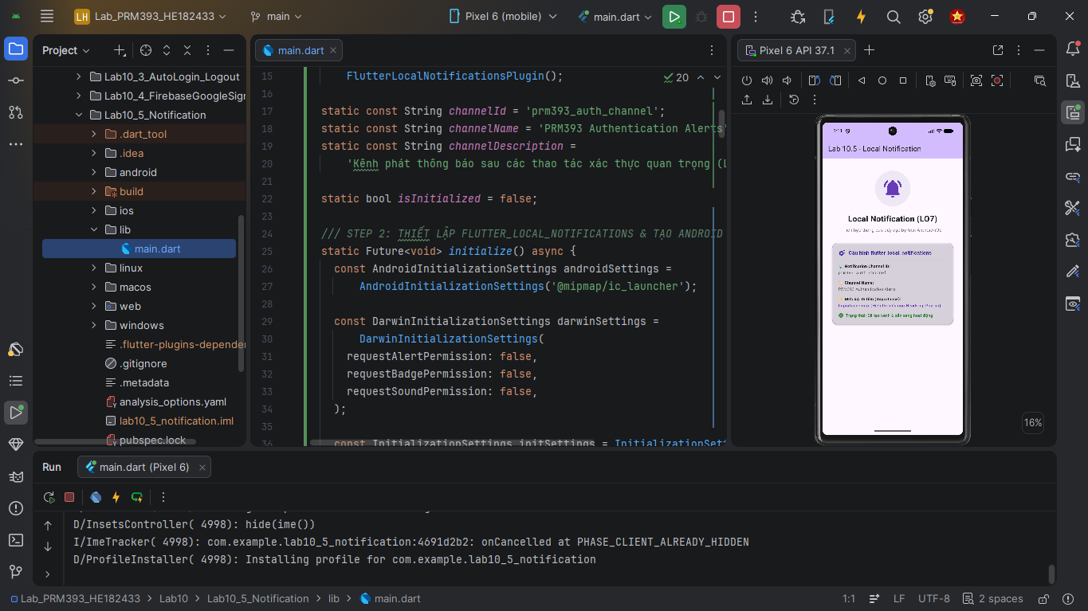
- Request notification permission (Android 13+)
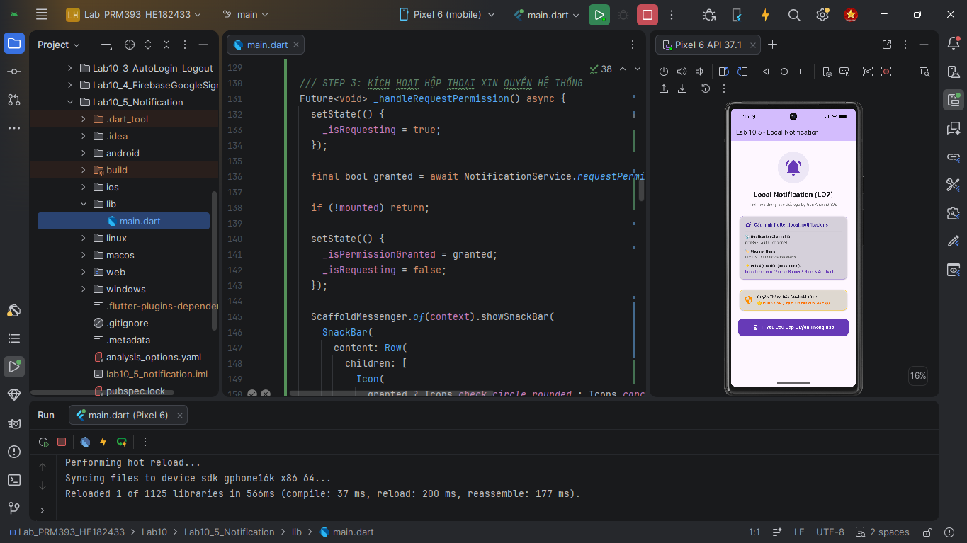
- Trigger notification manually for demonstration
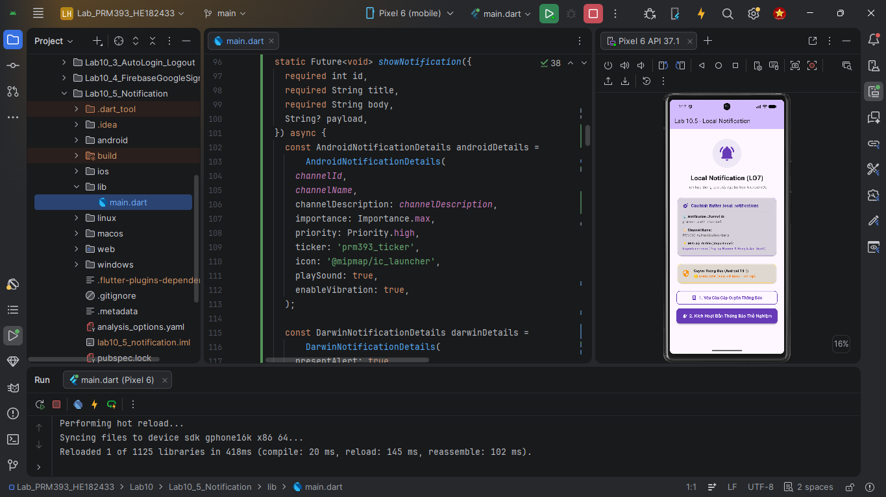
- Verify notification is displayed by the system
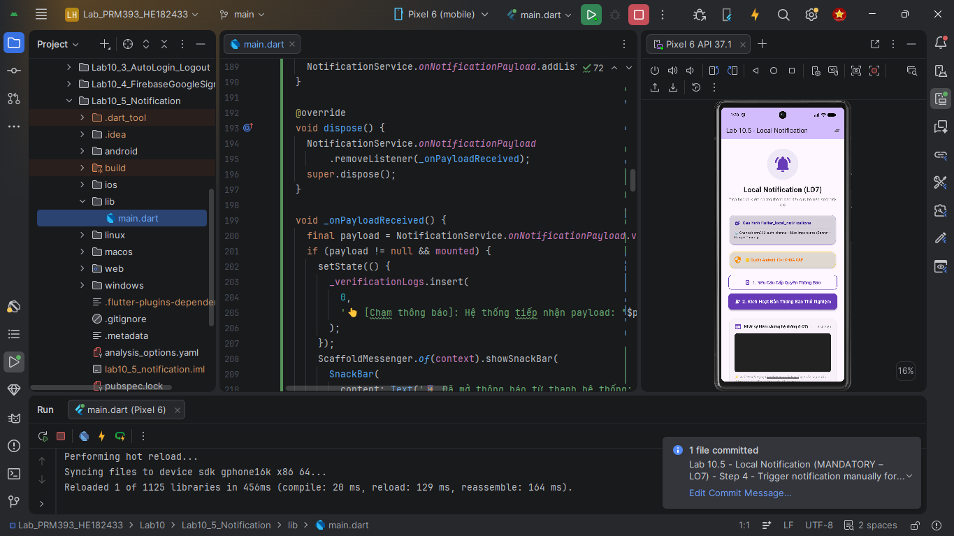
In the integrated project, the same notification method must be called after a successful user action (e.g. login success).
Expected Output
- Notification appears on the device
Lab10_Full – Final Integrated Project
Goal
Integrate all authentication and notification features into one complete application.
Integration Order (Recommended)
- Base project from Lab 10.1
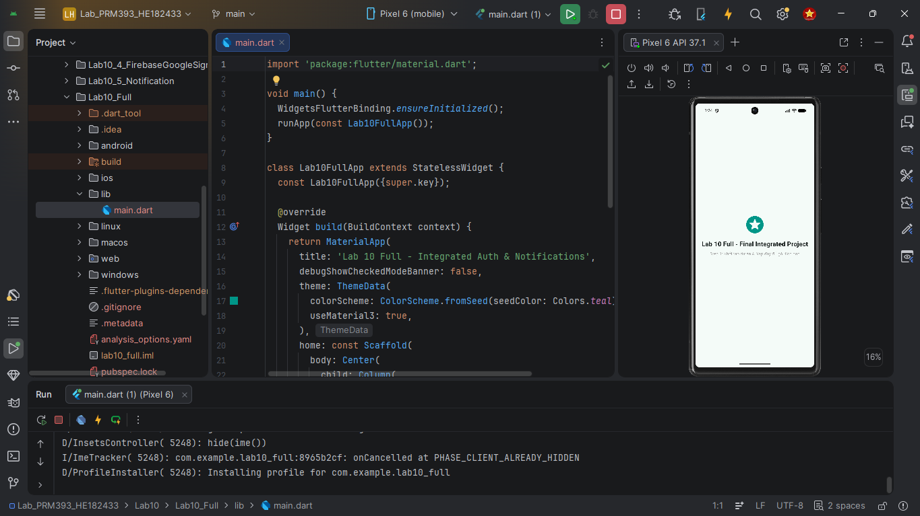
- Replace mock login with real API login (Lab 10.2)
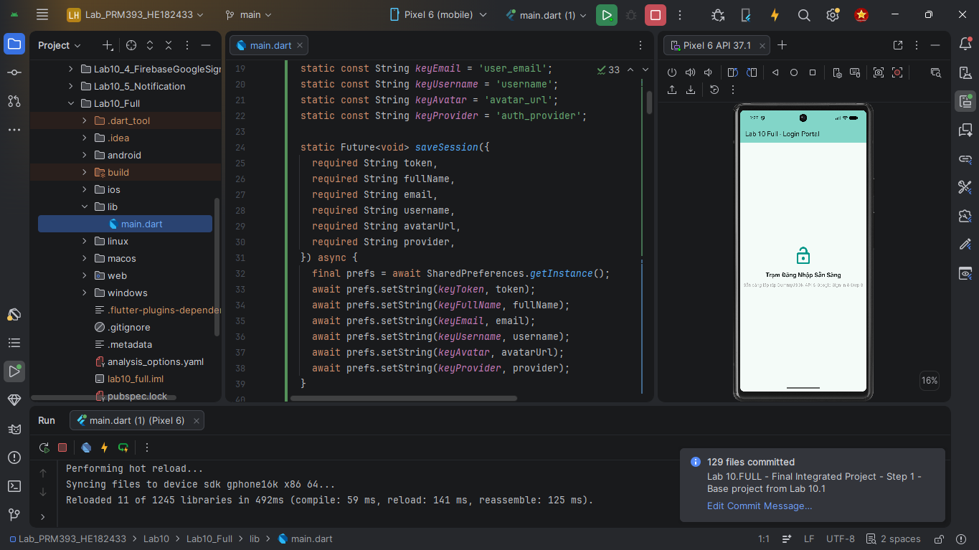
- Add session persistence and Splash routing (Lab 10.3)
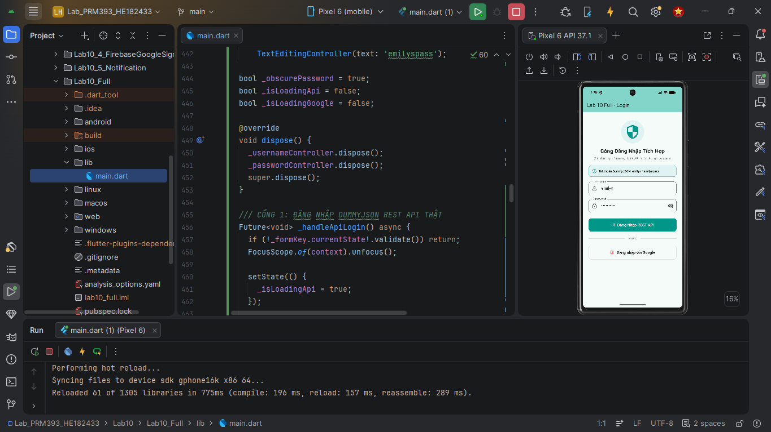
- Add Firebase Google Sign-In (Lab 10.4)
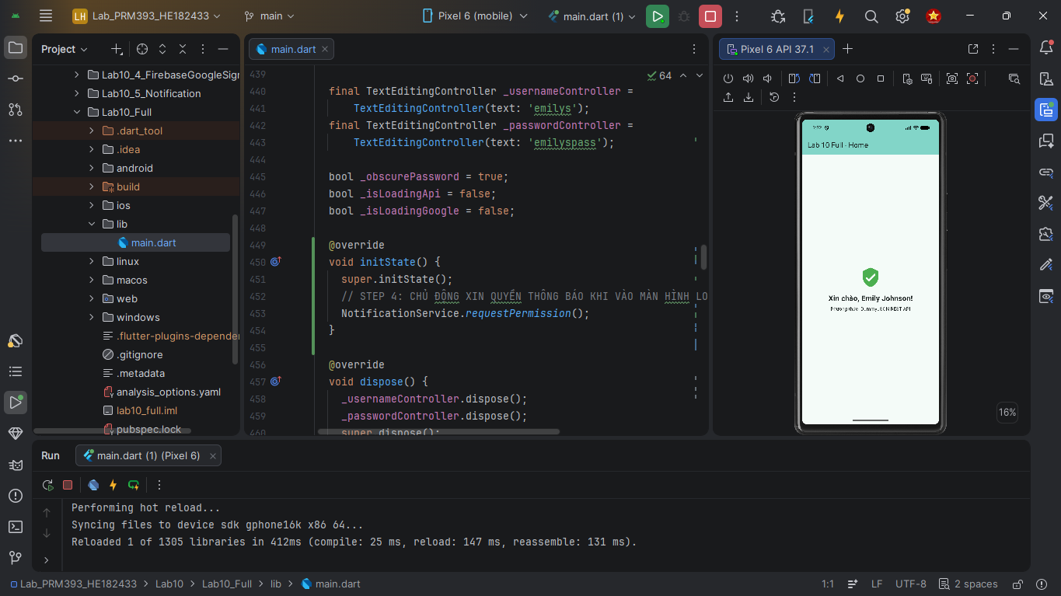
- Add Local Notification (Lab 10.5)
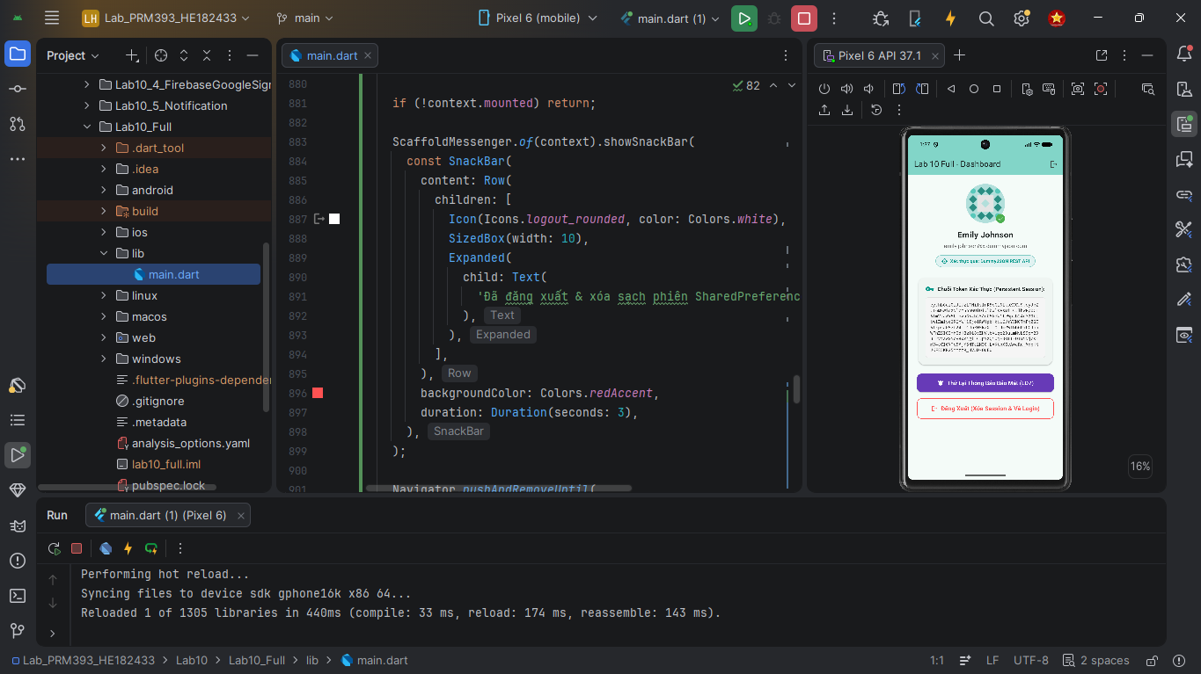
Minimum Required Features
- SplashScreen routing
- Real API login
- Auto-login and logout
- Firebase Google Sign-In
- Local notification integration
7. Final Checklist
- All 5 part projects run independently
- Lab10_Full integrates all required features
- Local notification works correctly
- Correct naming and submission format
8. Score Distribution (Percentage)
- Lab 10.1 – Mock Login: 15%
- Lab 10.2 – Real REST API Login: 20%
- Lab 10.3 – Auto Login & Logout: 25%
- Lab 10.4 – Firebase Google Sign-In: 20%
- Lab 10.5 – Local Notification (LO7): 10%
- Lab10_Full – Integrated Project: 10%
Total: 100%

